**PROJECT: 1 - Student survey**

**Project:**  - In United States, there are many stores in which a survey was conducted based on students i.e. how much they are spending on different kind of purchases like Video games, Indoor games, Toys, Books, Gadgets etc. In the data set (Student Survey), Store setting is the column that explains the Type of location in which the store is present. By using data set (Student Survey), try to extract the meaningful Insights.

**Industry Type:** – Retail Store

**Data set** - Student survey

**Problem Statement** - Create a Power BI Report:

**1. Tabular Visualization**

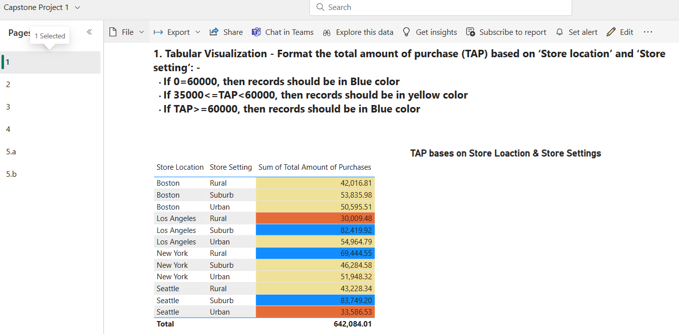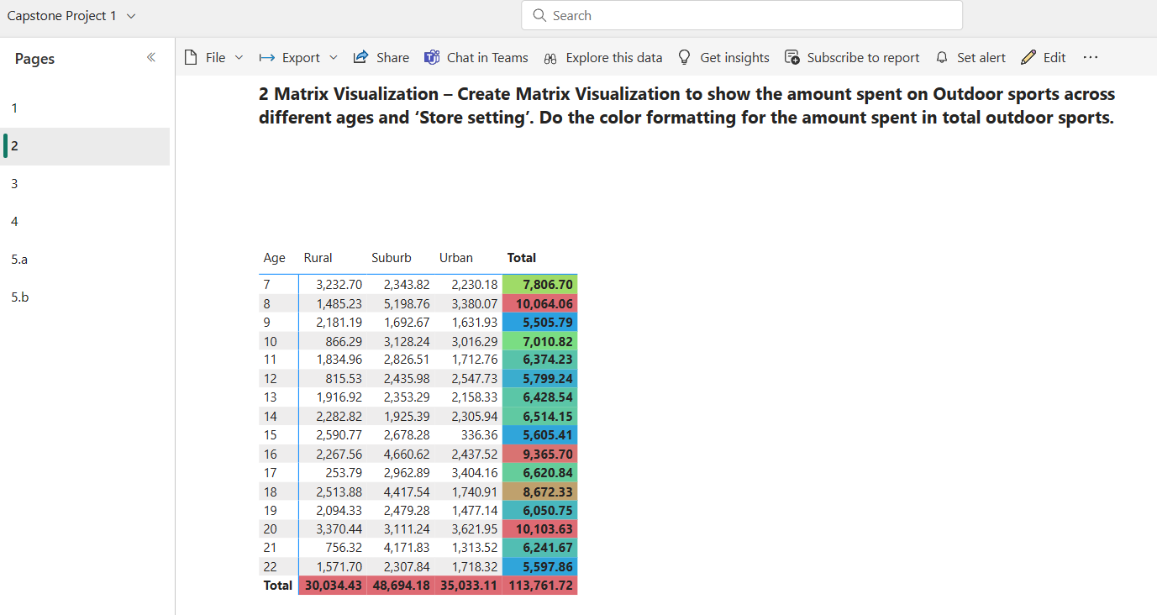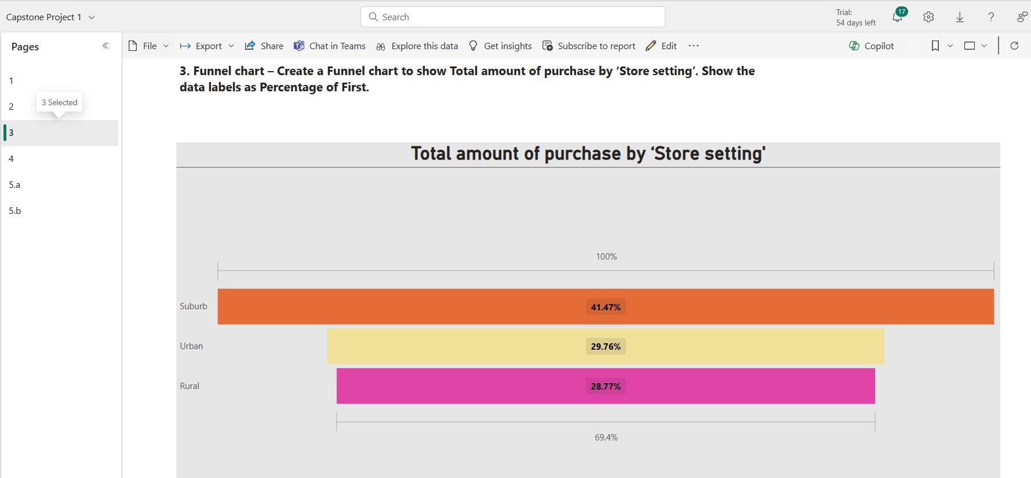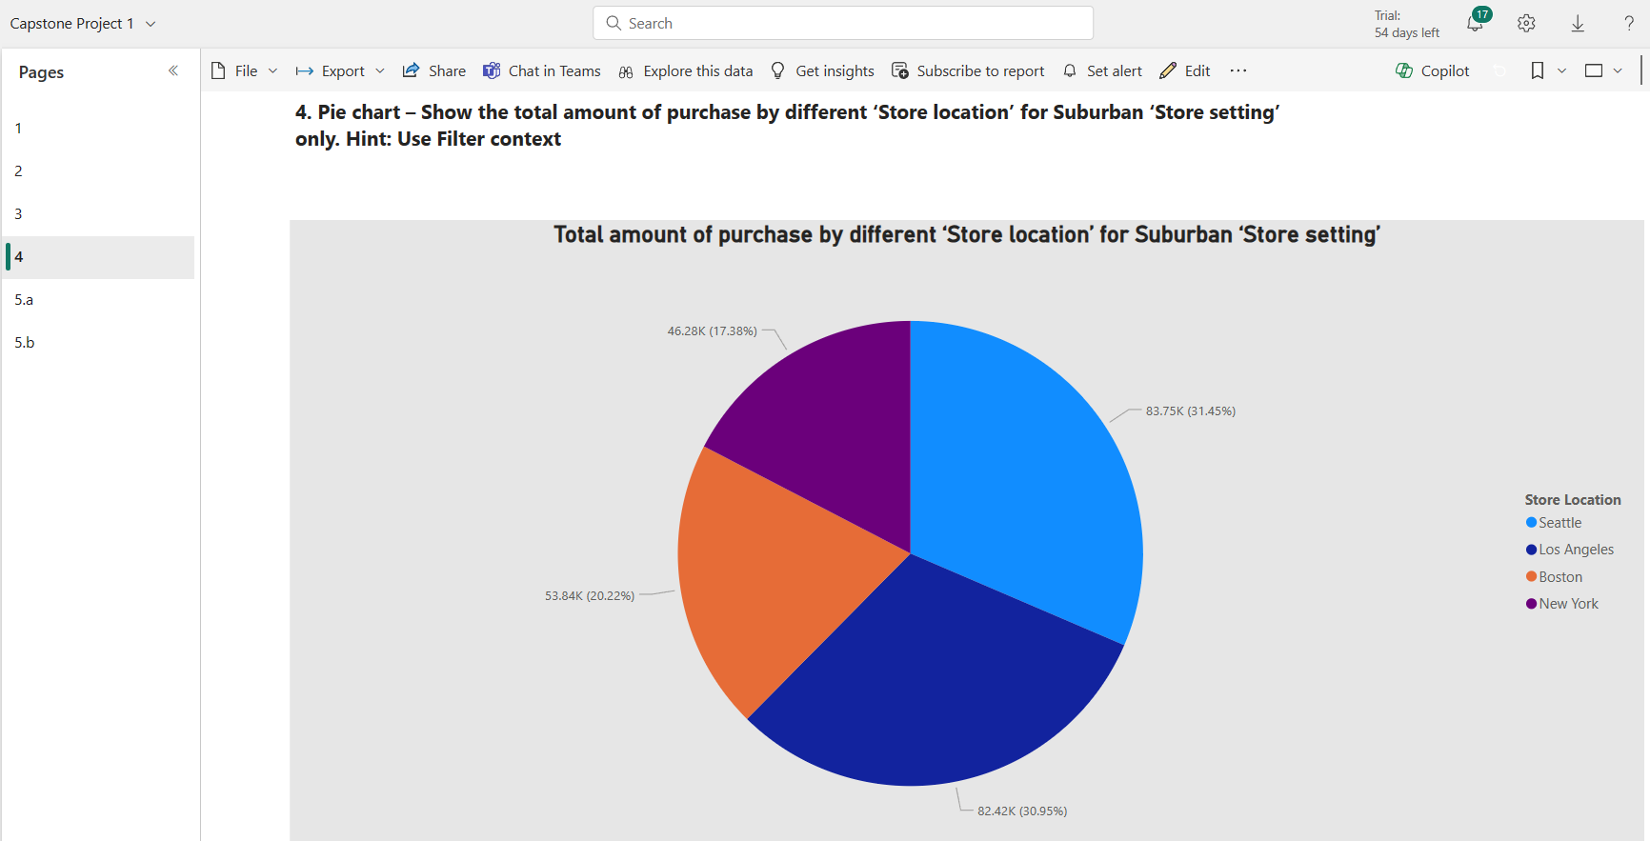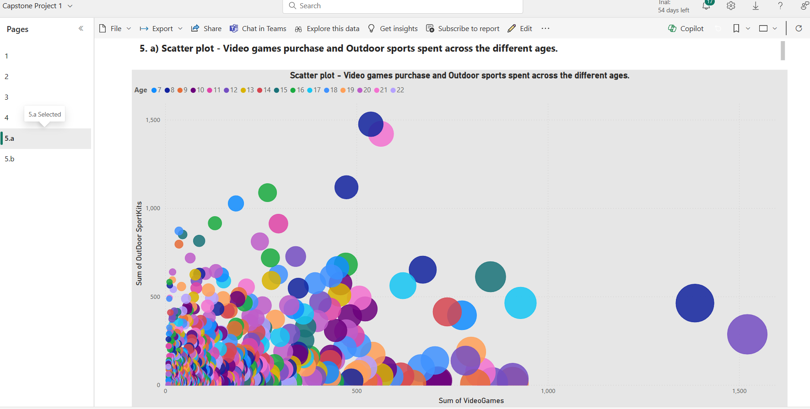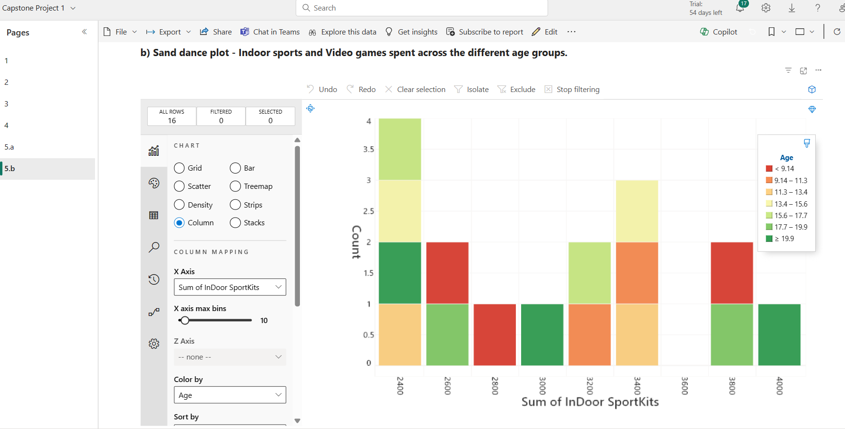

**6**. Restrict data access for the given users in User mapping table. For ex. Mani deals with Rural area only so she should be able to view the data which belongs to Rural only, not urban and suburban data.

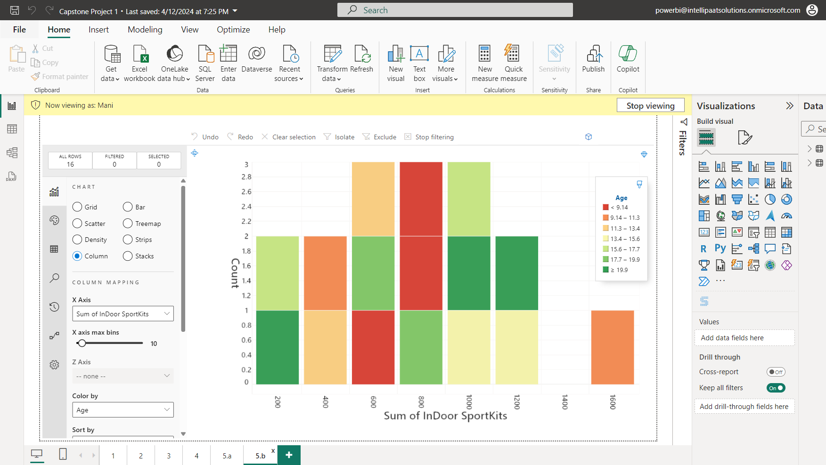

**7**. Publish the report on Power BI cloud service and Design the Master Dashboard consisting of Funnel chart and scatter plots. Then create a schedule refresh for six times in every 4 hours for the Dashboard in a day.

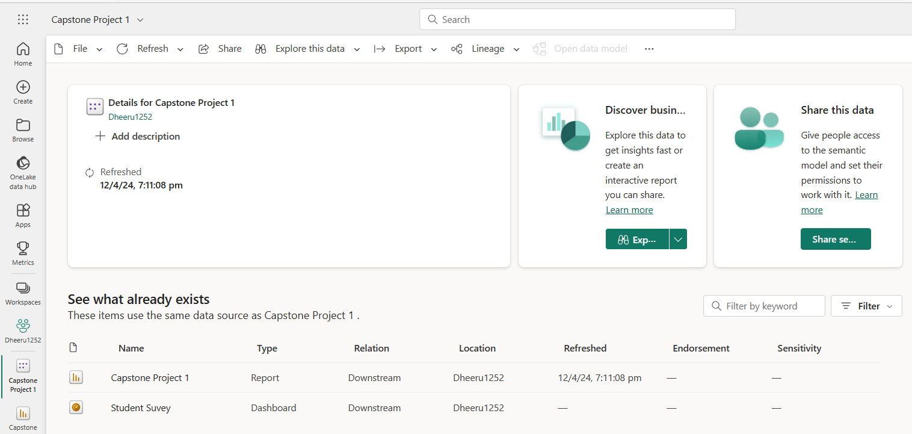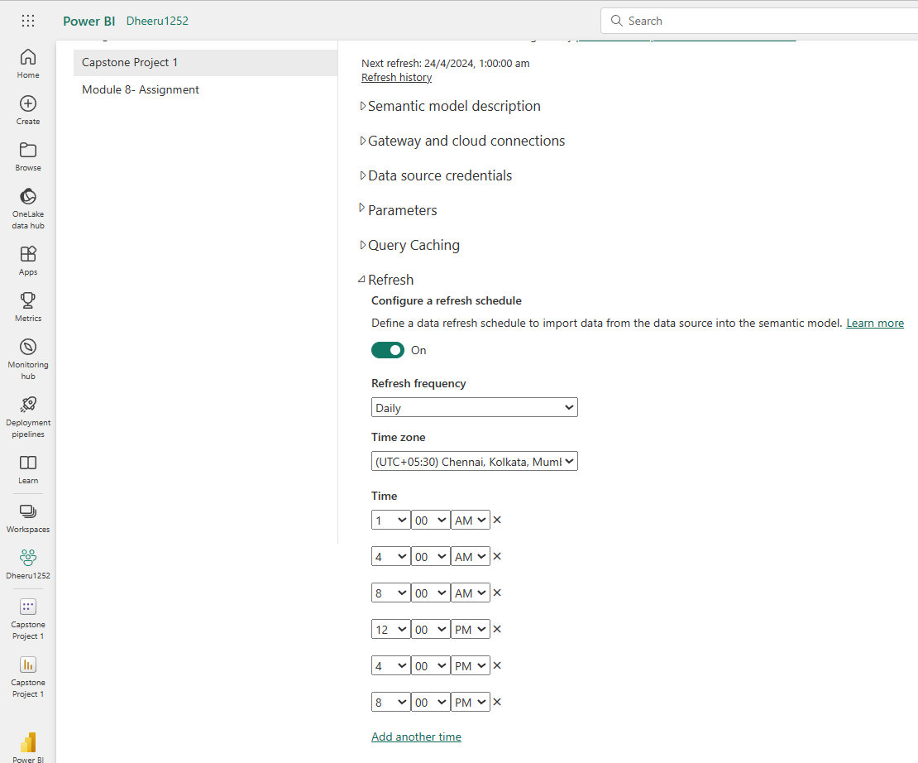

**8**. Use Q&A feature of Power BI –

a) To show average age of students

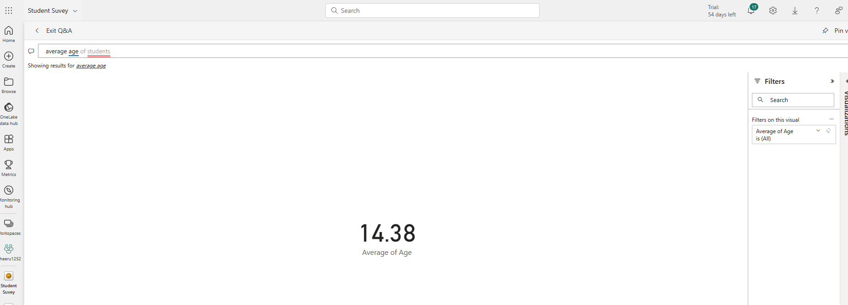

b) Donut chart for total amount of purchases by ‘Store location’

